What is ASP?
- ASP is a server side scripting technology that enables scripts (embedded in web pages) to be executed by an Internet server.
- An ASP file can contain text, HTML, XML and scripts.
- An ASP file has file extension “.asp”.
- When a browser requests an HTML file, the server just returns the file without doing any processing.
- When a browser requests an ASP file, IIS passes the request to the ASP engine (ASP.DLL) on the server.
- The ASP engine reads the file, line by line, and execute the script in the file which is marked as server script in <% %>.
  - <% _ _ _ %> contain the server side code in VBScript. The code outside the delimiter is Client side code and is as it is rendered to the client.
  - E.g. <%Response.Write(“hello”)%> or <%=”hello”%>.
- Finally, the output rendered is returned to the browser as plain HTML.
ASP Object:
- Request
- Response
- Session
- Application
- Server
- ObjectContext
- AspError
Type of Path
Every web server has a default directory and by default on IIS it is: C:\Inetpub\wwwroot\. Only content placed in this folder and its subfolder is accessible to clients on Internet.
- Physical Path: C:\Inetpub\wwwroot\Demos\default.html
- Absolute Path: http://ServerName:PortNo/Demos/default.html (URL)
- Virtual Path: /Demos/default.html
Configure IIS in Window 7
Control Panel -> Programs and Features -> Turn Windows features on or off
Select ASP, ASP.NET -> OK
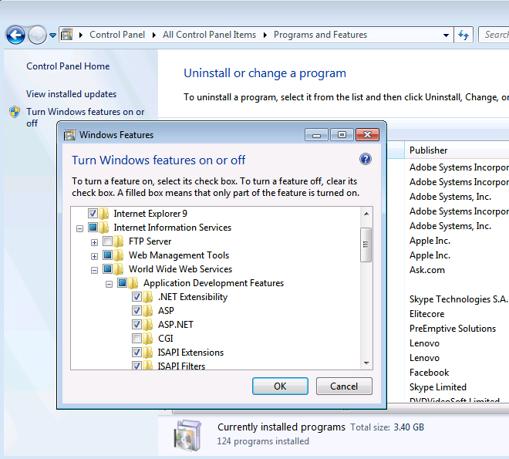

Example1
Hello ASP with server date
Example 2
WAP to generate the table of 10 in ASP
<!DOCTYPE html PUBLIC "-//W3C//DTD XHTML 1.0 Transitional//EN" "http://www.w3.org/TR/xhtml1/DTD/xhtml1-transitional.dtd">
<html xmlns="http://www.w3.org/1999/xhtml" >
<head>
<title>Multiplication Table of 10</title>
</head>
<body>
Multiplication Table of 10
<hr />
<table border="1">
<%For i=1 to 10 %>
<tr>
<td>10</td>
<td>*</td>
<td><%=i %></td>
<td>=</td>
<td><%=10*i %></td>
</tr>
<%Next %>
</table>

</body>
</html>

Example 3
<select size="31">
<%For i=1 to 31 %>
<%If(i=Day(Now)) Then %>
<option SELECTED><%=i%></option>
<%Else %>
<option><%=i%></option>
<%End If %>
<%NEXT%>
</select>

Working with Form Tag
<form action=”URL” method=”Post”…>
<input name=”n1” type=”text/password/submit/resetbutton/checkbox/radio/image”…>
<textarea name=”t1”></textarea>
<select name=”s1”…>
<option value=”v1”>v1</option>
<option value=”v2” SELECTED>v2</option>
</select>
</form>

Important points about the form submission
- Form tag cannot be nested inside another form tag.
- Input type’s button and reset and disabled elements name and value pair is not submitted to the server.
- Input type=”button” is used only for writing client side JavaScript code.
- Input type=”checkbox” submits name and value pair only if the checkbox is checked otherwise nothing is submitted. If value is not provided the default value posted is “on”.
- To group radio button, same name must be given to them. And only the name-value pair of the radio button selected will be submitted to server.
- For select, name of select and value of the optional selected is submitted to server.
- Select tag with size attribute is rendered as Listbox otherwise its rendered as DropDownList.
- If multiple options are selected in listbox, then with same name different value (multiple pairs) are submitted to server.
- For textarea, name of text area and value of textarea is submitted to server.
- Input type=”Image” behaves as submit button where as <img> tag renders static image.
- A form can have more than one submit button, but only the name-value pair of the submit button used to post the form is included with the request.
- If the form has input type=”file” to upload a file along with request then its enctype=”multipart/form-data” and method=”post”.

Example 4:
FormTagDemo.html
<form name="f1" action="display.asp" method="post">
First Name<input type="text" name="fn" />
<br />
Last Name<input type="text" name="ln" />
<br />
<input type="submit" name="sb" value="submit" />
<input type="reset" name="rb" value="Reset" />
</form>

Display.asp
<% fn=request.Form("fn")
ln=request.Form("ln")%>
Hello <%=fn& " " & ln %>

Example 5:
FontExample.htm
<form name="f1" action="fontdisplay.asp" method="post">
<input type="text" name="text" />
<br />
<input type="checkbox" name="bold" value="b" CHECKED />Bold
<input type="checkbox" name="italic" value="i" />Italic
<br />
<input type="radio" name="color" value="blue" CHECKED />Blue
<input type="radio" name="color" value="red" />Red
<input type="radio" name="color" value="green"/>Green
<br />
<select name="size">
<option value="1">1</option>
<option value="2">2</option>
<option value="3" SELECTED>3</option>
<option value="4">4</option>
<option value="5">5</option>
</select>
<br />
<input type="submit" name="s1" value="Give Effect" />

</form>
FontDisplay.asp
<%
txt = request.form("text")
if(request.form("bold") = "b") then
txt = "<b>" & txt & "</b>"
end if
if(request.Form("italic") = "i") then
txt = "<i>" & txt & "</i>"
end if

color = request.form("color")
size = request.form("size")

txt = "<font color="& color &" size="& size &">" & txt & "</font>"
response.Write(txt)
%>

Example 6:
<table border="1">
<%for each sv in Request.ServerVariables %>
<tr>
<td>
<%=sv %>
</td>
<td>
<%=Request.ServerVariables(sv) %>&nbsp;
</td>
</tr>
<%Next %>
</table>

